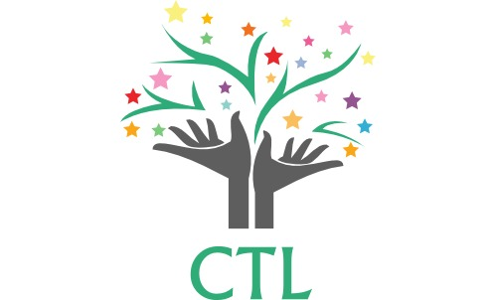
CENTER FOR TEACHING & LEARNING
Face-to-face, in-person Instruction
2020-2021 Public Health Planning Guidance
The following guidelines take into account the current information we have on the virus and appropriate methods to prevent its spread. We will be closely monitoring guidelines and information or any changes. In evaluating whether an individual has symptoms consistent with COVID-19, consider the following question: Have they recently begun experiencing any of the following in a way that is not normal for you?

- Feeling feverish or a measured temperature greater than or equal to 100.4 degrees
- Loss of taste or smell
- Cough
- Difficulty breathing
- Shortness of breath
- Headache
- Chills
- Sore throat
- Shaking or exaggerated shivering
- Significant muscle pain or ache
- Diarrhea
PREVENT: Practices to Prevent the Virus from Entering the School
- CTL Team members will self-screen. They will stay at home and report any COVID symptoms immediately to the school.
- A student with COVID-19 symptoms who has not been evaluated by a physician to test for COVID must stay home until the 14-day incubation period has passed. A student with symptoms who tested negative with two separate confirmations 24-hours apart or who has a doctor’s note with an alternative diagnosis may return to school.
- A student who has tested positive for COVID-19 or who has been with someone who has tested positive must stay home until the 14-day incubation period has passed.
- Temperatures of students will be checked at drop-off each morning. If the temperature is above 100.4, the student and siblings will not be allowed to enter the building.
- Hand sanitizer will be applied to each student entering the building.
- Students will be distanced 6-feet apart when entering the building and in the hallway.
- No adult will be allowed to enter the building except for school employees. Any communication must be through email.

RESPOND: Practices to Respond to a Lab-Confirmed Case in the School
- Any student who shows COVID-19 symptoms while at school will go to the CTL Wait Room until the student can be picked up by a parent or guardian.
- The areas used by the individual who shows COVID-19 symptoms while at school will be cleaned and disinfected.
- We will close off areas that are heavily used by the individual with the confirmed case until the non-porous surfaces in those areas can be disinfected unless more than 3 days have already passed since that person was on campus.
- We will notify all teachers, staff, and families of all CTL students if a COVID-19 confirmed case is identified among students, teachers or staff, steps will be taken to quarantine as needed. The class will quarantine for 14 days.
MITIGATE: Practices to Mitigate the Likelihood of COVID-19 Spread Inside the School
- We are limiting ALL class sizes to allow for social distancing in classrooms, in the hallway, outside and throughout the school. CTL faculty and staff will teach students good handwashing techniques, and all will sanitize and/or wash hands frequently.
- Students, teachers, and staff will be reminded to cover coughs and sneezes with a tissue or into their elbows. Tissues will be disposed of immediately and hands washed or sanitized.
- Daily disinfectant of all desks, tables, computers and surfaces that are shared morning and afternoon. Gloves will be provided for disinfecting.
- Adequate supplies of soap, hand sanitizer, paper towels, tissues, disinfectant wipes, cloth face coverings, and trash cans will be readily available on campus.
- Whenever possible, teachers will open windows to improve air flow, allowing outside air to circulate in the building.
- CTL will require the use of masks for adults and for students when it is developmentally appropriate and practical like outside PE. There may be times when students are able to socially distance and can remove the mask for a period of time.
- Students will be 6-feet apart in classrooms, in hallways, and outside.
- Classroom and snack/lunch tables will be placed 6-feet apart.
- Students will be seated 6-feet apart, and two per table on opposite ends of the table.
- Plexiglass shields/dividers will be placed on tables between the students
- Students will not share school supplies. Resources that are shared (books, etc.) will be wiped down with disinfectant after use.
- When feasible and appropriate, classes will gather outside rather than inside because of likely reduced risk of virus spread outdoors.
- There will be no student or family gatherings on the school grounds.
- Classes will go to recess and lunch as a class. Enrichment will be outside for PE and in their classrooms for art and music.
- No food will be purchased for Friday lunches.
- Backpacks, lunch bags or boxes, and water bottles must be labeled with child’s name.
- Students must bring a filled water bottle to school each day. Bottles will be refilled by teachers in the classroom.
- CTL will restrict visits in schools to only those essential to school operations.

